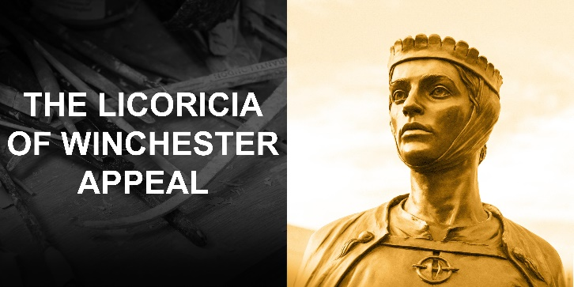

Fundraising for short films on Licoricia by Tracy-Ann Oberman

In 2022 HM King Charles, when Prince of Wales, visited our statue of Licoricia in central Winchester. This statue and our wider project:

- Educates people about England’s and Winchester’s important but little-known medieval Jewish Community.
- Informs about Winchester’s significant Royal medieval past.
- Promotes tolerance and the value of diversity in the national community, challenging prejudice.
- Inspires young people and women, illustrating the role of education in providing opportunities.

Licoricia was a medieval Jewish businesswoman, single mother, and leader in her community. She lived in the thirteenth century. Like many Jewish women of her time, she was highly educated. She made a major forced contribution to the building of Westminster Abbey and financed many other projects.

Her Jewish community suffered severe religious persecution before King Edward I forced them all out of England, and the prejudices formed at that time still linger today. The message of “Love they Neighbour as Thyself” at the base of the statue, shared by Jews, Christians and Muslims, is as important to follow now as it was in her time.

You can see from the Appendix following this letter that we have achieved much over the last four years and have reached over a million people with our messages. More information is on our website www.licoricia.org. There is however much still to do.

We would be very grateful for your support for our latest project. This is to produce some short videos about Licoricia. We know that the best way to spread our messages is to invest in Youtube-style videos, as people respond well to short visual clips. Two videos of about two to three minutes each will introduce children to our primary and secondary lessons at school before they are taught. The final video of a similar length will suit teachers and visitors to our website and the information board by the statue (from which the video will be accessible by QR code). We expect others such as Winchester’s Great Hall, the Tourist Information Office, the Holocaust Educational Trust and the University of Winchester to publish links to the video from their websites.
The videos will be acted by Tracy-Ann Oberman, the well-known Jewish actress from Coronation Street. Tracy-Ann has been recently acclaimed for her portrayal of Shylock in the Merchant of Venice 1936.
We anticipate that Tracy-Ann will be dressed in period costume and the videos will either be filmed in Winchester at an appropriate Norman venue such as the Great Hall, or in London. The production company will help us produce scripts, which will be sensitively tailored to deal with the subject. We know that Tracy-Ann will be sensitive to the needs and nuances of our project, which she supports, and will help us make this another work of art.
Our budget for this exciting new venture is £15,000. Of this we have already raised £6,000, leaving £9,000 to find. We would very much like to discuss this project with you and hope that you might be able to help us fund it.
With best wishes

William Carver (Secretary and Treasurer)
Appendix - Major achievements to date
Over £200,000 fundraised. Over a million people reached. 15,000 leaflets distributed in Winchester.
October 2024 – completion of primary lessons created with Hampshire County Council and available free from them and our website nationwide and to Hampshire schools
September 2023 – erection of information board by the statue of Licoricia
March 2023 – Hampshire County Council takes over ownership and maintenance of the statue
June 2022 – publication of our book ‘Licoricia of Winchester: Power and Prejudice in Medieval England’ (https://www.amazon.co.uk/Licoricia-Winchester-Prejudice-Medieval-England/dp/1399916386)
March 2022 – HM King Charles visits the statue of Licoricia. Coverage included Woman’s Hour and television
February 2022 – the statue of Licoricia is unveiled by the Lord-Lieutenant of Hampshire in the centre of Winchester, accompanied by a pop-up exhibition (HM King Charles was due to unveil but was unwell)
November 2021 – completion of secondary lessons created with Hampshire County Council (also available free as above). Licoricia is included in Edexcel’s ‘Migrants in Britain’ case study
September 2021 – Lucille Dweck completes painting of Licoricia in the Great Hall of Winchester Castle with King Henry III, as an illustration for our projects
Museums, talks and podcasts: Licoricia is included in Winchester’s City Museum and is part of the current British Library exhibition ‘Medieval Women’. The Historical Association held a series of highly successful talks online about medieval Jews, to UK history teachers, in association with the Jewish Historical Society of England. There have been numerous podcasts made, examples being Hampshire HistoryBites, Hampshire History Trust, Apple, History Extra, Footnoting History, the Campaign against Antisemitism, Winchester Cathedral, BBC History Extra, the Jewish Historical Society of England, the Tower of London, Princeton and Medieval Jewish Studies.

